**Mini Project Report on**



**Design and developing Mental health therapist chat bot.**



**Submitted in partial fulfilment of the requirement for the award of the degree of**

**BACHELOR OF TECHNOLOGY**

**IN**

**COMPUTER SCIENCE & ENGINEERING**

**Submitted by:**

**Student Name**  **University Roll No.**

**Adarsh Joshi**  **2018633**

***Under the Mentorship of***

**Dr. Guru Prasad M S**

**Assistant Professor**



**Department of Computer Science and Engineering**

**Graphic Era (Deemed to be University)**

**Dehradun, Uttarakhand**

**January-2024**



**CANDIDATE’S DECLARATION**

I hereby certify that the work which is being presented in the project report entitled **“Design and developing Mental health therapist chat bot”** in partial fulfilment of the requirements for the award of the Degree of Bachelor of Technology in Computer Science and Engineeringof the Graphic Era (Deemed to be University), Dehradun shall be carried out by the under the mentorship of **Dr. Guru Prasad sir, Assistant Professor**, Department of Computer Science and Engineering, Graphic Era (Deemed to be University), Dehradun.

Name    University Roll no.

Adarsh Joshi 2018633

**Table of Contents**

|  |  |  |
| --- | --- | --- |
| **Chapter No.** | **Description** | **Page No.** |
| Chapter 1 | Introduction | 04 |
| Chapter 2 | Literature Survey | 05 - 06 |
| Chapter 3 | Methodology | 07 - 09 |
| Chapter 4 | Result and Discussion | 10 - 11 |
| Chapter 5 | Conclusion and Future Work | 12 |
|  | References | 13 |

**Chapter 1**

**Introduction and Problem Statement**

* 1. **Problem Statement**

The advent of technology has revolutionized various industries, including healthcare. One such innovation is the use of chatbots in the provision of mental health services. The "Design and Developing Mental Health Therapist Chatbot" project aims to create a chatbot that can provide immediate, accessible and stigma-free mental health support.

* 1. **Introduction**

Despite the increasing awareness and need for mental health services, several barriers prevent individuals from seeking help. These include the stigma associated with mental health, lack of access to mental health professionals, and the high cost of therapy.

The project seeks to address these challenges by designing and developing a mental health therapist chatbot. This chatbot aims to provide immediate mental health support, bridging the gap between individuals and mental health services.

**Chapter 2**

**Literature Survey**

In the literature found regarding developing a mental health therapist chatbot, I discovered that although there has been a lot of work done in this particular area, very few of them use LSTM model.

I studied several research papers and here few of the important contributions are presented:

1. Artificially intelligent chatbots in digital mental health interventions: A Review by Elaine M. Boucher , Nicole Harake et al .
2. Naeun Lee et al. [2017] projected the execution of division utilizing NLTK. tongue ToolKit (NLTK) could be a python package that obliges provide forms of help for human lan-guage technology. it's built-in tokenizers. shoppers got to im-port the package and utilize the required reasonably tokenizer that is gift as capacities.
3. Sachin S. Gavankar et al. [2017] projected the crazy call tree rule for expectation. this type of call tree is that the make-shift version of the standard call tree. It creates this tree at runtime, supported queries, and keeps refreshing the tree on new user messages. take into account its operating for sickness expectation. during this rule, the symptoms recognized within the user inquiry square measure added as fry nodes to the foundation hub.
4. Zhenghua Li [2014] gave a model of the reliance program. within the standard strategy documented over the program creates a parsed tree for the desired sentence. within the chart-based reliance program, the tree created is modified over to a chart wherever the words within the sentences square meas-ure the vertices and also the reliance between the words is described by the perimeters. This info structure shows a supe-rior illustration of the parsed sentence. Parsing is often to be performed by the standard technique. However, chart based mostly program improves the visibility, coherence, and com-prehensibility of the program.
5. Fadhil A, Gabrielli S (2017) Addressing challenges in promoting healthy lifestyles: the al-chatbot approach. Paper presented at the Proceedings of the 11th EAI International Conference on Pervasive Computing Technologies for Healthcare, Barcelona, Spain,
6. Inkster B, Sarda S, Subramanian V (2018) An Empathy-Driven, Conversational Artificial Intelligence Agent (Wysa) for Digital Mental Well-Being: Real-World Data Evaluation Mixed-Methods Study. JMIR Mhealth Uhealth 6 (11):e12106. doi:10.2196/12106
7. Mental Health Foundation (2015) Fundamental facts about mental health. London8. Whiteford HA, Ferrari AJ, Degenhardt L, Feigin V, Vos T (2015) The global burden of mental, neurological and substance use disorders: an analysis from the Global Burden of Disease Study 2010. PloS one 10 (2):e0116820
8. Sansonnet J-P, Leray D, Martin J-C Architecture of a Framework for Generic Assisting Conversational Agents. In, Berlin, Heidelberg, 2006. Intelligent Virtual Agents. Springer Berlin Heidelberg, pp 145-15.

**Chapter 3**

**Methodology**

**Dataset Used:**

The required dataset was taken from kaggle , here it is: https://www.kaggle.com/datasets/narendrageek/mental-health-faq-for-chatbot

**Implementation of the Rule Based model chatbot** :

Start

Testing Chatbot

Normalization and Transformation

Sort Similarity scores in descending order

Finding Cosine Similarity

Clean data using NLTK

yes

Buzzer ON

Loading data and preliminary analysis

**Training Model:**  
  
  
  
  
  
**Training and Validation Accuracy:**

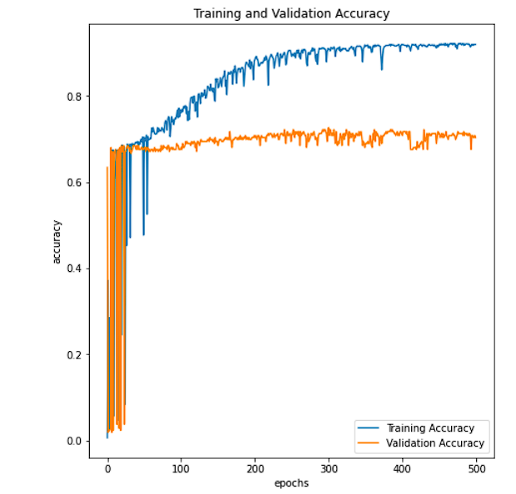  
  
  
  
**Training and Validation Loss:**

**Chapter 4**

**Result and Discussion**

I have used the Rule based model for training the chatbot. Initial steps involved acquiring a relevant dataset for data regarding mental health. The dataset was picked from Kaggle’s website.

For Rule based chatbot, **TF-IDF** was used along with **NLTK's tokenizer** for data-preprocessing. The processed data was tested against the expected outcome and **cosine similarity** was used for evaluation of the inputs given by the user.

**TF-IDF** is the abbreviated form for Term Frequency Inverse Document Frequency of records. It is used for the calculation of how relevant a word is in a series or corpus is to a text. The meaning is directly proportional to the number of times a word appears in the text but it is compensated by the word frequency in the corpus (data-set).  
The **Natural Language Toolkit (NLTK)** provides several tokenizers, which are tools used to divide strings into lists of substrings1. Here are a few examples:

1.Word Tokenizer: This tokenizer splits a string into words and punctuation.

2. WordPunct Tokenizer: A simpler, regular-expression based tokenizer, which splits text on whitespace and punctuation.

3. Sentence Tokenizer: This tokenizer splits a string into sentences.

Below are the few screenshots regarding the interaction with the chatbot:



  
  
  
  
  
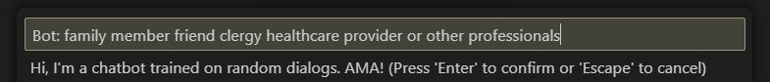

**Chapter 5**

**Conclusion and Future Work**

I have used the Rule based model for training the chatbot. This chatbot can be helpful for people struggling with mental health issues, without stigmatising them and meanwhile make them aware of their conditions and the solutions available.

**TF-IDF** was used along with **NLTK's tokenizer** for data-preprocessing. The processed data was tested against the expected outcome and **cosine similarity** was used for evaluation of the inputs given by the user.

In the future, I want to research and implement the possibilities and vast capabilities provided by the Generative based chatbots.Generative models do not rely on predefined responses. They come up with new replies from scratch. Machine Translation techniques are typically used in generative models.

One such example is the OpenAI’s Large Language Model based chatbot. It’s built on OpenAI’s proprietary series of generative pre-trained transformer (GPT) models3. These models are trained on vast amounts of data to produce human-like text1. ChatGPT is designed to interact in a conversational way, capable of answering follow-up questions, admitting its mistakes, challenging incorrect premises, and rejecting inappropriate requests. Using this transformer model and using relevant data for mental health issues and the possible solutions , the transformer model (i.e the generative based chatbot) will be immensely effective , user-friendly for the patients struggling with mental health issues.

**References**

1. Sansonnet J-P, Leray D, Martin J-C Architecture of a Framework for Generic

Assisting Conversational Agents. In, Berlin, Heidelberg, 2006. Intelligent Virtual

Agents. Springer Berlin Heidelberg, pp 145-156

2. Hussain S, Ameri Sianaki O, Ababneh N A Survey on Conversational

Agents/Chatbots Classification and Design Techniques. In, Cham, 2019. Web, Artificial

Intelligence and Network Applications. Springer International Publishing, pp 946-956

3. Fadhil A, Gabrielli S (2017) Addressing challenges in promoting healthy lifestyles:

the al-chatbot approach. Paper presented at the Proceedings of the 11th EAI

International Conference on Pervasive Computing Technologies for Healthcare,

Barcelona, Spain,

4. Inkster B, Sarda S, Subramanian V (2018) An Empathy-Driven, Conversational

Artificial Intelligence Agent (Wysa) for Digital Mental Well-Being: Real-World Data

Evaluation Mixed-Methods Study. JMIR Mhealth Uhealth 6 (11):e12106.

doi:10.2196/12106

5. Effectiveness and Safety of Using Chatbots to Improve Mental Health: Systematic Review and Meta-Analysis

Source: [Effectiveness and Safety of Using Chatbots to Improve Mental Health: Systematic Review and Meta-Analysis - PMC (nih.gov)](https://www.ncbi.nlm.nih.gov/pmc/articles/PMC7385637/)  
  
6. Artificial Intelligence for Chatbots in Mental Health: Opportunities and Challenges by Kerstin Denecke et al.

Source: [(PDF) Artificial Intelligence for Chatbots in Mental Health: Opportunities and Challenges (researchgate.net)](https://www.researchgate.net/publication/353726195_Artificial_Intelligence_for_Chatbots_in_Mental_Health_Opportunities_and_Challenges)